**PETER BARREDO**

**Question #1**

Answer: D

**Question #2**

Answer: B

**Question #3**

Answer: B and C

**Question #4**

**Create Table**

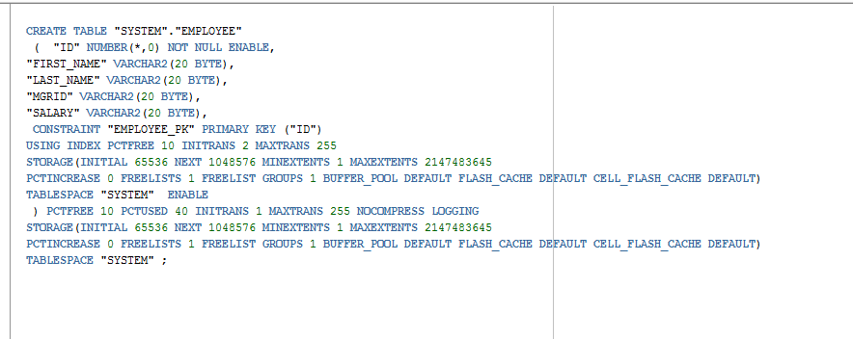

Answer is in the java workspace

**Question #5**

Class.forName –This loads the class dynamically at runtime. It obtains a reference to the class object with the fully qualified class name.

**Question #6**

Statement – statement interface cannot accept input. Useful when you are using static SQL statements at runtime

PreparedStatement – the interface can accept input. Invoke frequently

**Question #7**

**ResultSet**

ResultSet rs;

try {

rs = pstmt.executeQuery(query);

List list = populateRS(rs);

} finally {

if (rs != null) {

rs.close();

}

}

**Statement**

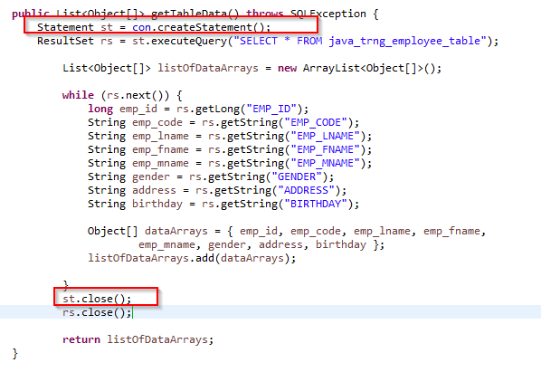

**Connection  
